Dear Colleague,

Please consider submitting an original research article for potential publication in the fourth symposium of the International Consortium for Mental and Social Health in Musculoskeletal care (I-MESH).

As you know, CORR® publishes selected proceedings from meetings like ours. CORR believes, and we agree, that the topic we all are interested in—advancing the diagnosis and treatment of mental and social health opportunities among people presenting with musculoskeletal symptoms—deserves this coverage, and we now have the opportunity to publish the best work from our meeting and our organization and its colleagues in CORR. Publishing your work in CORR as part of these proceedings has many advantages both for you and for I-MESH, not least of which is that it will be accessible in full-text form to every AAOS member (and thousands of members of other societies around the world); about 45,000 people see CORR’s electronic table of contents each month. Access to CORR is also available for free to I-MESH members at i-mesh.org and membership is open to all with no membership fees.

We seek manuscript submissions on this topic of any of the following types:

(1) Original clinical research (level IV or above),
(2) Original laboratory research, or
(3) Systematic review or meta-analysis (the latter must include only randomized trials).

Selective (book-chapter-style) review articles cannot be considered. As always, all papers will be peer reviewed, and the standard to publish a paper in these proceedings is the same as applies to unsolicited research in CORR®.

Please read carefully the attached summary of CORR’s approach to scientific reporting (it’s easy to follow), and consider using one of CORR’s available online article-building tools to write and format your article; see screenshot just below for where to find the tools (red arrows) and their instructions (blue arrows) on www.clinorthop.org.

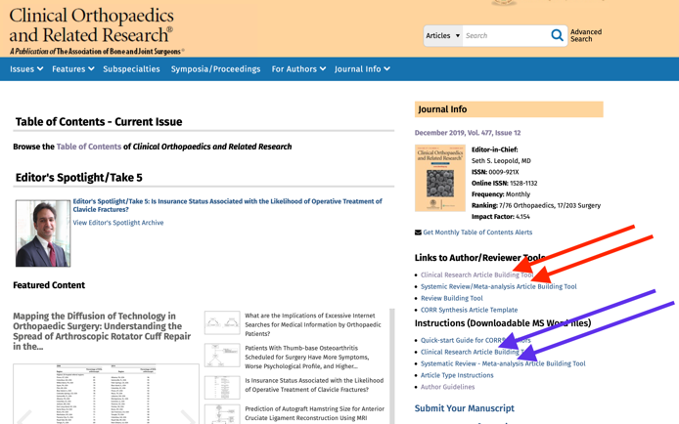

Submission Deadline: June 1, 2024

Submission Process:
•Login at https://www.editorialmanager.com/corr/,
•Select “Submit new manuscript”
•Select “Solicited Symposium/Proceedings” as the article type, and
•Select “Papers from the Fourth International Consortium for Mental and Social Health in Musculoskeletal Care” from the drop-down menu.

Screenshots depicting these steps are below our signatures.

It is very important that you submit the work as a Symposium/Proceedings paper under the correct title (Papers from the Fourth International Consortium for Mental and Social Health in Musculoskeletal Care), and not as “clinical research” or “basic research” in order for your work to be included.

Of course, you can submit your work before June 1st; earlier submissions will be considered, reviewed, and published as they come in. Electronic publication will occur within several weeks of final acceptance, so publication of work submitted early will not be delayed.

Finally, if you do not now serve as a peer reviewer for CORR, we encourage you to volunteer. The more people who are interested in the topics that we explore at I-MESH who serve as reviewers, the more effectively and consistently we’ll be able to help authors consider the issues that matter in their own research. If you are willing, please email the editor-in-chief (Seth Leopold, MD) directly, at SLeopold@clinorthop.org.
We are very excited about this project, and we know you share our enthusiasm. The editor-in-chief of CORR®, Seth Leopold, is likewise enthusiastic and supportive. The amount and diversity of the material we covered at our meeting should make this a fascinating and important selected proceedings in CORR®.

Please direct any questions about the meeting to any of us, and any questions about the proceedings or publication of your work in CORR® to Dr. Leopold (sleopold@clinorthop.org).

Very respectfully,

Trevor Lentz, PT, PhD, MPH
President, I-MESH

Julia Blackburn, MD
Program Committee Chair, I-MESH

David Ring, MD PhD
Deputy Editor, Clinical Orthopaedics and Related Research®

Ana-Maria Vranceanu PhD
Deputy Editor
I-MESH Liaison to Clinical Orthopaedics and Related Research

Submission Process:

From www.editorialmanager.com/corr …

Click on “Submit New Manuscript” …
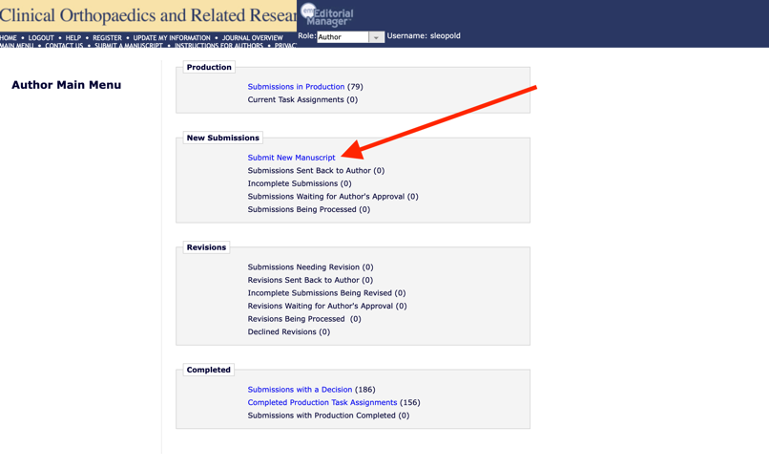

Choose “Symposium/Proceedings/Workshop” …

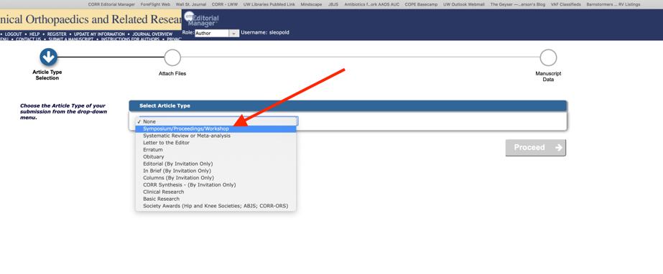

Select “Papers from the Fourth International Consortium for Mental and Social Health in Musculoskeletal Care”

